Outbreak

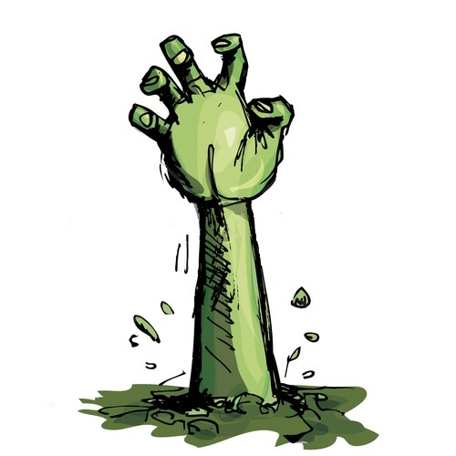

Kristofer Escobar

October 15, 2012

Version 1.0

Game Rules / Mechanics

1. The goal of Outbreak is to reach New York State, where the main character Damon hopes to find refuge. The player must kill all the zombies in each level and survive to move on the next.
2. If the Player is attacked by zombies and loses all of their heart containers, the player will lose and start the level all over again.
3. The player starts with 3 heart containers and 3 lives. If the player loses all heart containers, he will then lose 1 life. If the player loses all of their lives, the game is over.
4. The live for each level carry over to the next level, but the heart containers do not. The heart containers for the player are reset every level.
5. There will be 5 levels, each of which will represent a different state the player must pass through.
6. The player can earn extra lives by finding lives scattered around the level. If a player finds a health pack, their lives will increase by one.
7. The player will accumulate a score for each zombie they kill.
8. The player’s rewards are heart, health packs and weapons.
9. The player will be awarded extra health if they find heart containers, extra lives when they find a health pack and cause more damage when they find stronger weapons.
10. The player will find three weapons throughout the game a knife, a chain, and a gun.
11. The weapons will each deal a different amount of damage. The chain will be the weakest of the three weapons and will only deal 1 damage point. The knife will be slightly stronger and deal 3 damage points. Finally the gun, which will be a range weapon, will deal the most damage and inflict 5 damage points to enemies.
12. Weapons will be scattered throughout the game. The Player will start with the chain weapon, and will have to find the knife and gun weapons.
13. The enemies will be the zombies and they will be plentiful and vary in size.
14. The zombies will attack the player by scratching and biting them.
15. The player will be able to take out zombies by repeatedly hitting them with their weapon.
16. The player will not have any power-ups, only health rewards to replenish life.
17. The player cannot earn power-ups but they can find hearts and health packs.
18. As the game advances it will get increasingly difficult. The amount of zombies and the amount of damage they inflict to the player will increase.
19. The game ends when the player reaches New York State and finds refuge from the zombie outbreak.
20. Each level will depict a different state, but the rules will remain relatively the same. The only exception will be that different weapons will become available later in the game and that each level will get progressively harder than the pervious.